LAB SHEET 3 – Program Reasoning

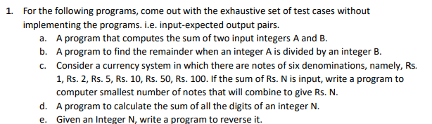

|  |  |  |  |  |  |
| --- | --- | --- | --- | --- | --- |
| Test Cases | Problem 1a | Problem 1b | Problem 1c | Problem 1d | Problem 1e |
| 1 | <1,-1 – 0> | <1,-1 – 0> | <100 – 1> | <10 – 55> | <123 – 321> |
| 2 | <1,2 – 3> | <1,2 – 1> | <21 – 3> | <100 – 5050> | <15 – 51> |
| 3 | <-1,-2 - -3> | <-1,-2 - -1> | <63 – 4> | <5 – 15> | <21 – 12> |
| 4 | <100,100 – 200> | <100,100 – 0> | <15 – 2> | <20 – 210> | <6 – 6> |
| 5 | <-123,-123 - -246> | <100,21 – 16> | <18 – 4> | <15 – 120> | <101 – 101> |



|  |  |  |  |  |  |
| --- | --- | --- | --- | --- | --- |
| Test Cases | Problem 1a | Problem 1b | Problem 1c | Problem 1d | Problem 1e |
| 1 | P | P | P | P | P |
| 2 | P | P | P | P | P |
| 3 | P | P | P | P | P |
| 4 | P | P | P | P | P |
| 5 | P | P | P | P | P |

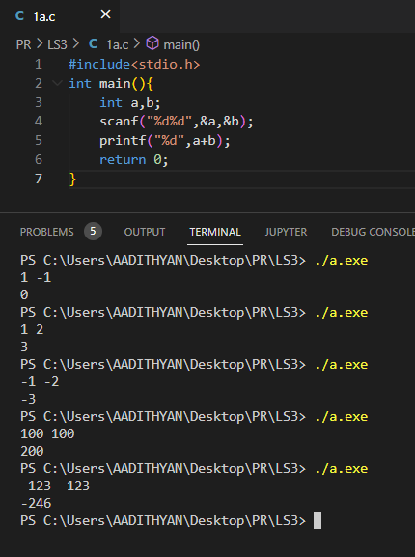

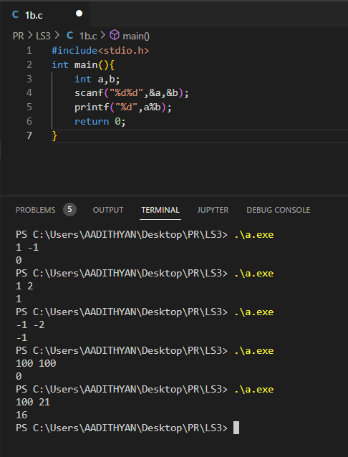

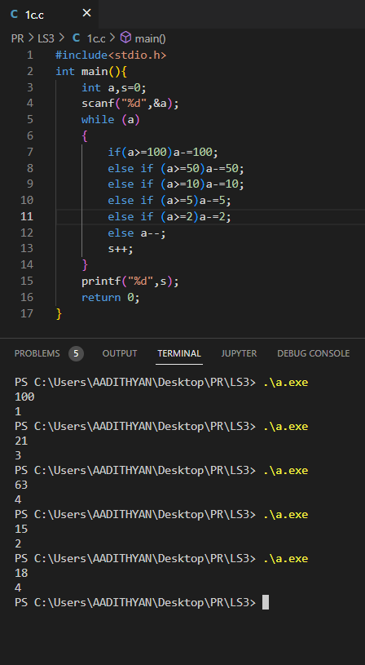

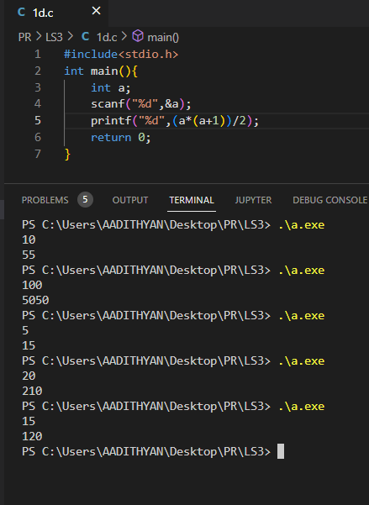

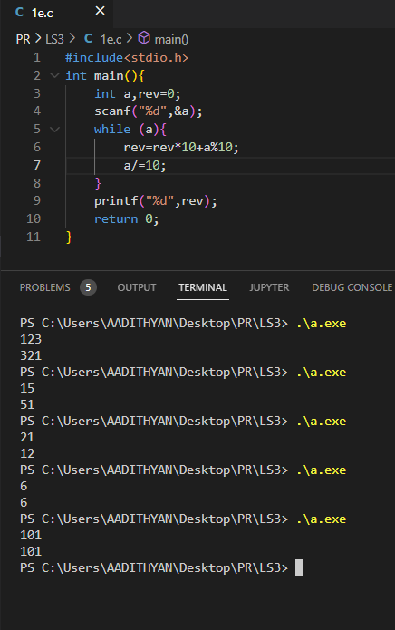



Integers greater than 2147483647 as this is the limit for integer in c.

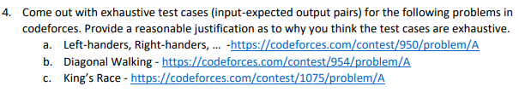

A.

1,4,2 - 6

5,5,5 - 14

0,2,0 - 0

30,70,34 – 128

And so on

B.

5,RUURU - 3

17,UUURRRRRUUURURUUU - 13

100,UUUUUUUUUUUUUUUUUUUUUUUUUUUUUUUUUUUUUUUUUUUUUUUUUUUUUUUUUUUUUUUUUUUUUUUUUUUUUUUUUUUUUUUUUUUUUUUUUUUU - 100

100,RRURRUUUURURRRURRRRURRRRRRURRUURRRUUURUURURRURUURUURRUURUURRURURUUUUURUUUUUURRUUURRRURRURRRUURRUUUUR - 67

100,UUUUUUUUUUUUUUUUUUUUUUUUUUUUUUUUUUUUUUUUUUUUUUUUUUUUUUUUUUUUUUUUUUUUUUUUUUUUUURUUUUUUUUUUUUUUUUUUUUU - 99

3,RUR - 2

1,R – 1

And so on

2^100 input output pairs

C.

5,3,5 - White

5,3,5 - Black

2,2,2 - Black

1000000000000000000,1000000000000000000,1000000000000000000 - Black

1000000000000000000,1,1 - White

2,1,1 - White

1234567890123456,1234567889969697,153760 – White

And so on

More than 10^36 input output pairs can be obtained.